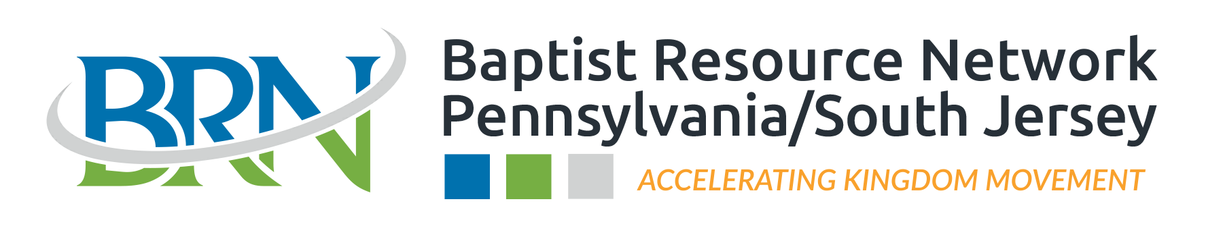

COOPERATIVE PARTNERSHIP AGREEMENT

CHURCH NAME:
The Baptist Resource Network (BRN) of Pennsylvania/South Jersey (PA/SJ) is one of 41 state conventions related to the Southern Baptist Convention (SBC). Our central office of operation, the “Hub” as we call it, is in Harrisburg, PA and our team is located strategically throughout our regions. The BRN geography of servicing typically consists of Pennsylvania and Southern New Jersey and we are comprised of hundreds of churches situated across four regions throughout this geography: West Region, Central Region, Greater Philadelphia Region, and South Jersey Region.
The BRN has a clear vision to see every church within its geography become a healthy, multiplying church. Our mission is to carry out that vision and the mission of Accelerating Kingdom Movement. There are three characteristics of all healthy churches: they engage missionally in the community, make disciples, and they develop leaders. The main priority of the BRN is helping your church strengthen these three behaviors so that you can expand the Kingdom of God.

Jesus commissioned His Church to “go and make disciples of all nations” (Matthew 28:19). We realize that no one individual or local church can accomplish this mission alone, so we choose to partner as we can accomplish more together than we can separately.

The BRN highly values partnership with your church. We love cooperating to help churches become effective in fulfilling the Great Commission of our Lord Jesus Christ. True partnership works when churches are involved and committed together to reach this goal. We want and desire to work with you to accomplish this mission.

Financial giving to the Cooperative Progam is one of the largest ways we can accomplish more together as this directly funds the ministry and missions efforts of the BRN and the SBC which allow the continued servicing of churches and the advancement of the Gospel in our geographical areas, the nation, and the world. The more your church is able to contribute, the more we are able to advance the Kingdom.

Each local church is autonomous and the BRN has no ecclesiastical authority over the church. Churches affiliate with the BRN voluntarily to work together to reach the world for Christ. Affiliated churches shall be member churches of the BRN, which allows messengers from the church to vote on business matters at the BRN Annual Gathering and the SBC National Convention.
We are so grateful for churches like yours that desire to do ministry together for the sake of the 14+ million people in our four regions that do not have a relationship with Jesus.
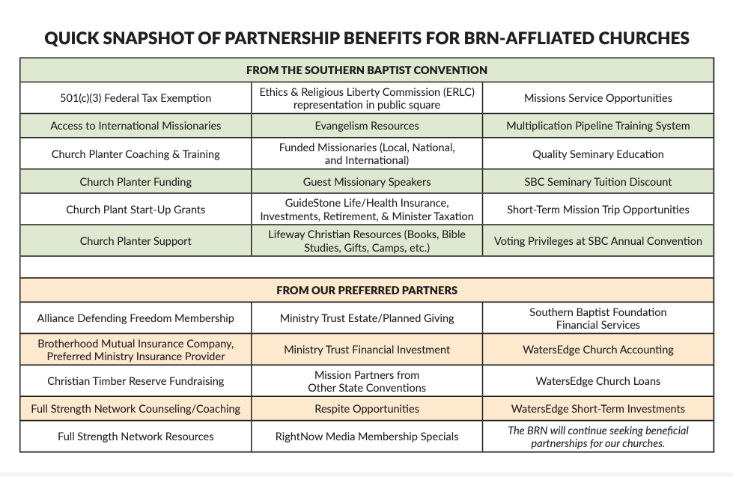
PARTNERSHIP BENEFITS
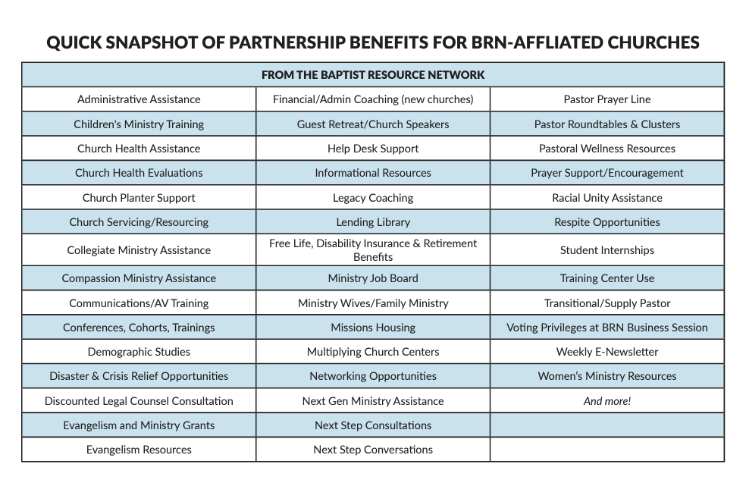
These benefits along with a comprehensive look at the BRN can be found in our online version of the Your BRN Family guide here: www.brnunited.org/yourbrnfamily.

PARTNERSHIP AFFILIATION PROCESS

- Pastor (and church elders, if desired) meets with a BRN team member(s) to discuss the BRN and complete the attached Affirmation Statements. Discussion will include the BRN Constitution & Bylaws, Baptist Faith & Message, the Cooperative Program, support of the BRN direction & vision, and the Annual Church Profile (ACP).

- The Church shall submit all the items from the following checklist to the BRN by mail or email (helpdesk@brnunited.org)
Baptist Resource Network Hub
4620 Fritchey Street
Harrisburg, PA 17109
The signed Affirmation Statements and Validation on the following pages;
Church Information sheet (below);
A contribution to the Cooperative Program;
A copy of your church Constitution & By-laws;
PA Churches: Church to submit current Clearances for the Lead/Senior pastor(s);
NJ Churches: Church to submit recent (within 5 years) background checks for the
Lead/Senior pastor(s);
A brief statement indicating your church is in compliance with state laws as it pertains to the protection of minors; Abuse Prevention Compliance Statement
A brief statement indicating why the church desires to join together in Gospel ministry with the BRN to advance the Great Commission as identified in Matthew 28:19-20 and the Biblical implementation plan outlined by Jesus in Acts 1:8. Gospel Ministry Statement
A brief statement indicating whether or not your church affirms the latest version of the Baptist Faith & Message. Please include in this statement a discussion of any portion of the Baptist Faith & Message that your church or church leadership does not affirm or agree with in faith and practice.

- The BRN will communicate back to your church once the affiliation has been processed and approved. You should receive both an SBC Identification number as well as a financial giving number from the BRN upon completion of the affiliation.
  - The SBC ID Number will be used to identify your church in the nationwide SBC database. It will allow you to file the Annual Church Profile, post job postings on sbc.net, participate in the Southern Baptist Convention Annual Meeting, make purchases through LifeWay, update your church info in the SBC database, etc.
  - The financial giving number is issued by the BRN and is used when submitting Cooperative Program or other contributions to the BRN. This number ensures that your gift is applied properly in our contribution system.

Partnership Affirmation Statements

Affirmation #1: We, the (church name),

of (street address)

, , do hereby
(City) (State) (Zip)
request affiliation with the Baptist Resource Network. We desire to participate in the Christian mission, fellowship, and behaviors (Intentional Discipleship, Leadership Development, and Missional Engagement) of the Baptist Resource Network and the Southern Baptist Convention.

The BRN Constitution & By-laws states a cooperating church is one that regularly contributes to the Cooperative Program, affirms in belief and practice the most recent Baptist Faith & Message as adopted by the SBC in annual session, and regularly completes the Annual Church Profile (church statistical report). Our congregation has voted to affirm or approve this action on (insert date).

Affirmation #2: (Please initial the blank before each statement that the church affirms.)

- Our church affirms the most recently adopted doctrinal statements of the Southern Baptist Convention called the Baptist Faith and Message, as a fair representation of the doctrinal position of our church.

- Our church affirms that it desires to take advantage of educational, inspirational, church servicing, and organizational business activities of the Baptist Resource Network and the Southern Baptist Convention.

- Our church will make a regular financial contribution through the Cooperative Program which supports cooperative missions in advancing the Great Commission both locally and globally. Our church is committing to which of the following:
[Enter a dollar amount in A or a percent in B, then check the frequency of giving]
A. Fixed dollar amount of $ annually, which will be given…
Monthly, Quarterly, or Annually.
B. Percentage amount, % of undesignated tithes and offerings, which will be given…
Monthly, Quarterly, or Annually.

- Each year our church will complete the Annual Church Profile (ACP) that indicates the strength and health of our individual church ministry.

- Our church affirms that we are compliant with all state laws and regulations as it pertains to protecting children from abuse and has implemented church-wide policies as a protection for minors. (Churches out of compliance shall remain as non-affiliated)

- Our church affirms that if at any time the partnership with the BRN is no longer desirable, communication will be made as soon as possible.

- Our church affirms to pray for the partnership and the work of the BRN.
Please Complete the Following Church Information
Official Name of Church
Preferred Mailing Address
City, State, and Zip Code
Location of Worship if Different from Above
City, State, and Zip Code
County
Name of Pastor
Name of Pastor’s Spouse
Name of Church Secretary or Admin Assistant ________________________________________
Church Website Address
Church Phone
Church Incorporation Date
Church Office Hours
Church Email Address
Primary Ethnic/Racial Demographic
Secondary Ethnic/Racial Demographic
Primary Language Spoken
Average Worship Attendance

Please Complete the Primary Contact Information Below

Name
Position in Church
Address
Phone
Cell Phone
Email
Partnership Validation & Covenant

Our church has prayerfully considered the ministry, organization, and mission efforts of the BRN and Southern Baptists. We believe our church, and the cause of Christ, will benefit from this partnership with the BRN and the SBC. We affirm this affiliation agreement, the Baptist Faith & Message, agree to contribute to the Cooperative Program, and complete the Annual Church Profile. We have asked questions where necessary and agree to covenant together as partners in the Gospel.
[Please complete all three signature spaces below]

1. Print Name
(Pastor)

Signature Date
(Pastor)

2. Print Name Title
(Authorized Clerk, Elder/Deacon, or Trustee)

Signature Date
(Authorized Clerk, Elder/Deacon, or Trustee)

3. Print Name Title
(Authorized Clerk, Elder/Deacon, or Trustee)

Signature Date
(Authorized Clerk, Elder/Deacon, or Trustee)

(Please retain a copy of this filing for your church records)

We are excited about partnering together for the Gospel! Please feel free to reach out to us if you have a need. We can be reached through the following ways:
Toll-free: 1.800.451.6599
Call or text: 717.652.5856
Email: helpdesk@brnunited.org
www.brnunited.org
Find us on social media: @BaptistResourceNetwork

Revised January 2024

