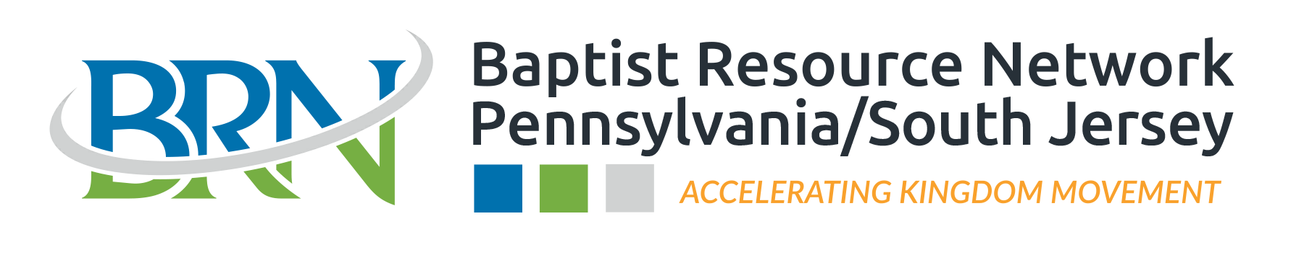
Evangelism Grant Application
(Revised 3/29/2022)
Please read the following information carefully to understand the evangelism grant application process and to ensure your church’s eligibility.

Every 4 minutes and 18 seconds someone in the BRN’s network area dies without a personal relationship with Jesus. The BRN defines “evangelism” as the proclamation of the Gospel in an effort to help people understand the salvation that comes through faith and trust in Jesus Christ, which is done in love. The BRN provides evangelism grants to cooperating churches in order to spur on and facilitate evangelism efforts within the BRN’s geographical region to reach the 14+ million people who do not know Jesus Christ as their Savior.

General Grant Information:
- The BRN shall consider grant requests that are for Events or Projects geared towards Evangelism in the church’s community, or Training to equip the people of the church to effectively evangelize. Grants will not be given where there is no plan or opportunity to proclaim the Gospel. Grants qualify for funding when there is a plan to have a concentrated time of engagement where the Gospel is clearly shared, and people have the opportunity to respond to this presentation. This can be corporate sharing or on an individual basis.
- Funds are only available to BRN churches who are in good standing with the BRN and who meet the eligibility and application requirements.
- Requests MUST be requested and submitted at least 30 days prior to the church’s event. The BRN needs up to 30 days to research and process each grant application.
- Send completed form to helpdesk@brnunited.org.
- Requests of $1,000 or more will result in a call from the BRN to discuss the request in more detail.
- All requests must be received at the BRN office by November 15th for grants in December of this calendar year.
- All requests will be considered and approved according to the “Grant Eligibility Policy” set forth by the BRN Executive Board, which includes regular church giving to the Cooperative Program and ACP reporting.
  - Flexibility of these requirements may be extended to churches actively working with the BRN on an evangelism strategy for the church.
- Evangelism grants will be payable only to the BRN church applying and will be paid via check or direct deposit.
- Evangelism funds are made available through Cooperative Program giving.
- The BRN reserves all rights to approve or deny a request for any and all reasons that they deem appropriate and reasonable.
- If awarded with an Event or Project grant greater than $250, the BRN will provide 75% of the awarded amount to the church prior to the Event or Project. Once the detailed Event or Project summary and pictures are received by the BRN the remaining 25% will be released (exceptions may be granted upon the discretion of the BRN).

Church Requirements Prior to Grant Request: The Church Shall…
- Have a clear plan for the presentation of the Gospel during the event.
- Have a plan to contribute financially to the event at the level of at least 50% of the total cost.*
- Meet the following conditions:
  - The church should have contributed at least $1,000 to Cooperative Program through the BRN within the last 12 months.
  - Church plants should be giving 6% of their undesignated receipts to the Cooperative Program through the BRN.
  - Unincorporated Church Plants in the missional community phase shall work with the BRN on an individual basis to determine grant eligibility.
  - The church should have completed the most recent Annual Church Profile (ACP) report as requested by the Southern Baptist Convention.

Church Requirements After a Grant is Approved:
- Following the Event or Project, please send pictures along with a detailed summary of at least one page typed of your event to helpdesk@brnunited.org. This summary should share what took place during the event, how the Gospel was shared in the event setting, how many Gospel conversations took place, and how many people accepted Christ.
- Following a Training, please send a brief typed summary of the training to helpdesk@brnunited.org. This summary should share how the church is now better equipped for evangelism.
- Any unused funds or funds not utilized for the intended purpose should be returned.

[Please see the next page for the Grant Application]

Grant Application
(Use additional blank pages as needed)

Church Name:
Name on checking account if different from above
Church Mailing Address:
Phone: Email:
Pastor’s Name:
Event Leader’s name:
I have read & understood the grant information as explained on page one: Yes No
Outreach Event Name:
Outreach Event Date:
Total event cost: $
*Amount you are requesting: $
Evangelism Type: (Event, Project, or Church Training)
Give details of your event/project/training & how BRN funding would be spent:
What is the anticipated outcome?
For Events/Projects, will there be a clear Gospel Presentation at the event? Yes No
If yes, how will it be presented?
For Events/Projects, was there, or will there be evangelism training prior to the event? Yes No
If yes, what training was it?
If no, would you like the BRN to assist with a training or help implement training? Yes No
What type of evangelism training or strategy does your church currently use?

Acknowledgement:
I acknowledge that the above information is accurate and correct to the best of my knowledge and that the application may be denied, partially funded, or fully funded based on the sole discretion of the BRN.

Signature: Title:

Printed Name: Date:

